**Week 4 – LAB2**

1. **First question: Lucky number**

Write a program that print your lucky number. Name your class LuckyNumber. The output must be as the following:

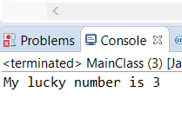

**Solution:**

public class LuckyNumber{

public static void main (String []args) {

System.out.print("My lucky number is 3");

} //end of main

} // end of class

1. **Second question: print information**

Write a Java program that prints the following:

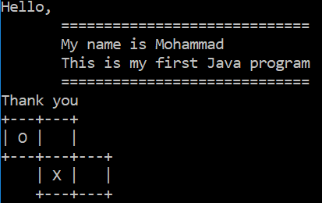

**Note 1:** Change the output so it prints your name in the third line.

**Note 2:** use \n and \t

**Solution:**

public class Java1

{

public static void main(String [] args)

{

System.out.println();

System.out.println("Hello,");

System.out.println(" =============================");

System.out.println(" My name is Khalid"); //name changed

System.out.println(" This is my first Java program");

System.out.println(" =============================");

System.out.println("Thank you");

System.out.println("+---+---+");

System.out.println("| O | |");

System.out.println("+---+---+---+");

System.out.println(" | X | |");

System.out.println(" +---+---+");

System.out.println();

}}

1. **Third question: multiplication table**

Write a Java program that prints the multiplication table of 9 as the following:

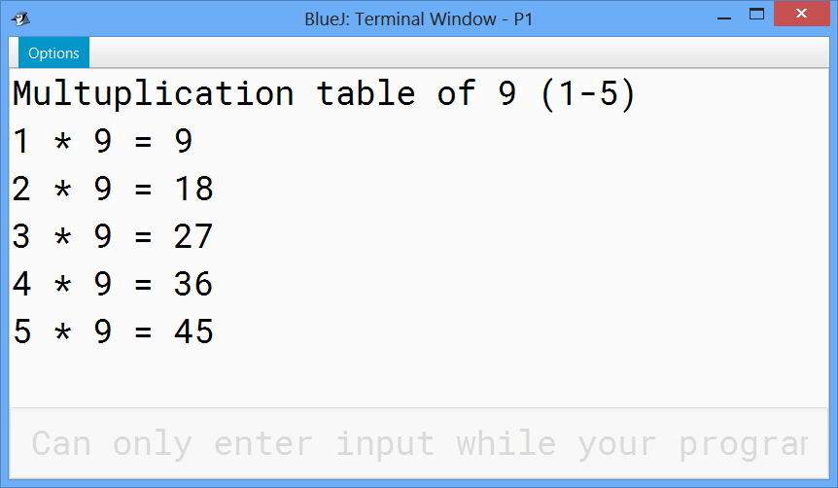

**Solution:**

public class MultTab

{

public static void main (String [] arg)

{

System.out.println("Multuplication table of 9 (1-5)");

System.out.println("1 * 9 = " + 1*9);

System.out.println("2 * 9 = " + 2*9);

System.out.println("3 * 9 = " + 3*9);

System.out.println("4 * 9 = " + 4*9);

System.out.println("5 * 9 = " + 5*9);

}

}

1. **Fourth question: Hello program!!!**

Scanner class in java library is used to read keyboard input.

Write a program that do the following:

* Ask the user to enter his/her full name.
* Read the input and store it in the variable (name)
* Print a welcome message with the user name.

**Solution:**

import java.util.Scanner;

public class Midterm{   
public static void main (String[] args){  
//Ask the user to enter his/her full name.

System.out.println("Enter your full name");

//Read the input and store it in the variable (name)

Scanner in = new Scanner (System.in);   
String name= in.nextLine();

//Print a welcome message with the user name.

System.out.println("Welcome, " + name);  
}}

1. **Fifth question: Seconds converter**

Write java program that allow the user to enter:

* The number of seconds
* The number of minutes
* The number of hours

Print the corresponding total number of seconds

**Typical run of the program**

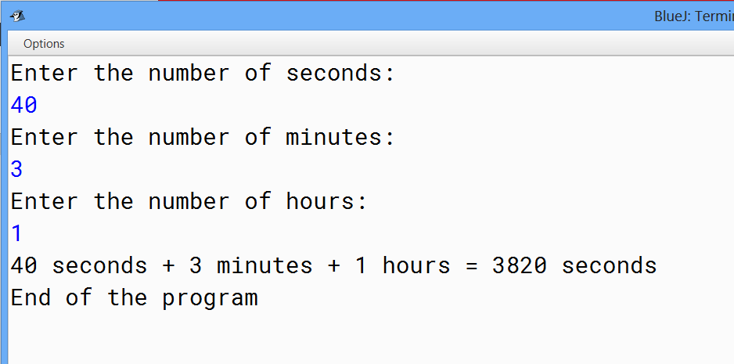

**Solution:**

import java.util.Scanner;

public class SecondsConverter{

public static void main (String [] args) {

Scanner in = new Scanner(System.in);

System.out.println("Enter the number of seconds: ");

int s = in.nextInt();

System.out.println("Enter the number of minutes: ");

int m = in.nextInt();

System.out.println("Enter the number of hours: ");

int h = in.nextInt();

int totalSeconds = s + m*60 + h*3600;

System.out.println(s + " seconds + " + m + " minutes + " + h + " hours = " + totalSeconds + " seconds" );

System.out.println("End of the program");

}}

1. **Sixth question: SAR bills calculator**

Create java program that ask the user to enter an amount in Saudi Riyal.

The program must print the minimum number of bills required to get the given amount.

The program should also print the number within each kind of bill.

***Typical run of the program:***

***Scenario 1:***

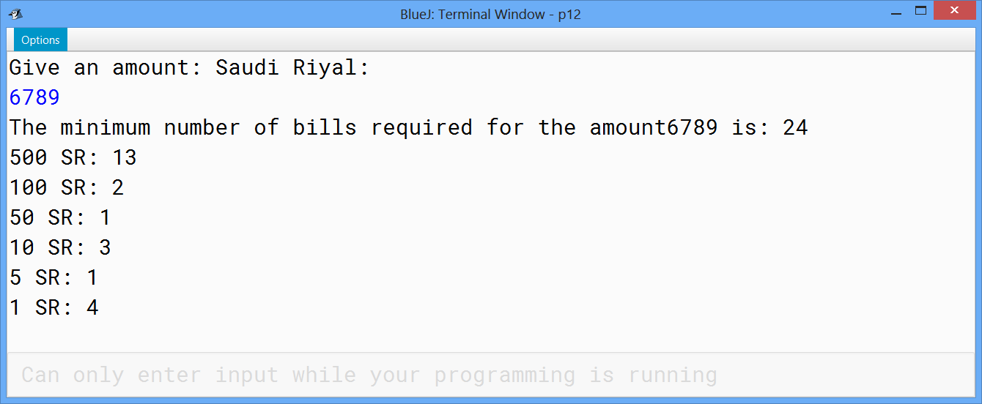

***Scenario 2:***

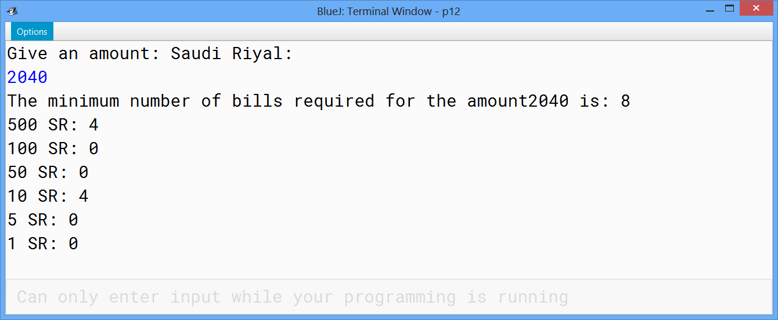

**Solution:**

import java.util.Scanner;

public class SarBillsCalculator

{

public static void main(String [] args)

{

Scanner in = new Scanner(System.in);

System.out.println("Give an amount: Saudi Riyal: ");

int x = in.nextInt();

int amount=x;

int nb_500 = amount/500;

amount = amount -nb_500 * 500;

int nb_100 = amount/100;

amount = amount -nb_100 * 100;

int nb_50 = amount/50;

amount = amount -nb_50 * 50;

int nb_10 = amount/10;

amount = amount -nb_10 * 10;

int nb_5 = amount/5;

amount = amount -nb_5 * 5;

int nb_1 = amount;

int totPaper =nb_500+nb_100+nb_50+nb_10+nb_5+nb_1;

System.out.println("The minimum number of bills required for the amount" + x + " is: " + totPaper);

System.out.println("500 SR: "+nb_500);

System.out.println("100 SR: "+nb_100);

System.out.println("50 SR: "+nb_50);

System.out.println("10 SR: "+nb_10);

System.out.println("5 SR: "+nb_5);

System.out.println("1 SR: "+nb_1);

}

}